Question 1

CODE

OUTPUT

Expected mu : 5

Calculated mu : 4.993626031893664

Expected sigma : 3

Calulated sigma : 3.0088907477542435

Question 2

CODE

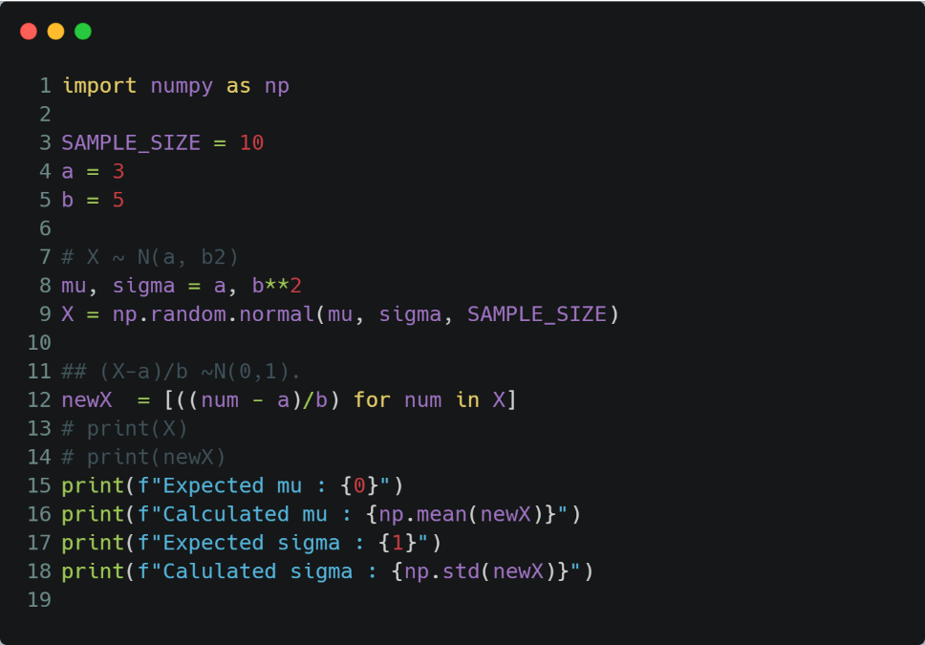

OUTPUT

Expected mu : 0

Calculated mu : 0.024964099603948825

Expected sigma : 4

Calulated sigma : 4.986155837499869

Question 3

CODE

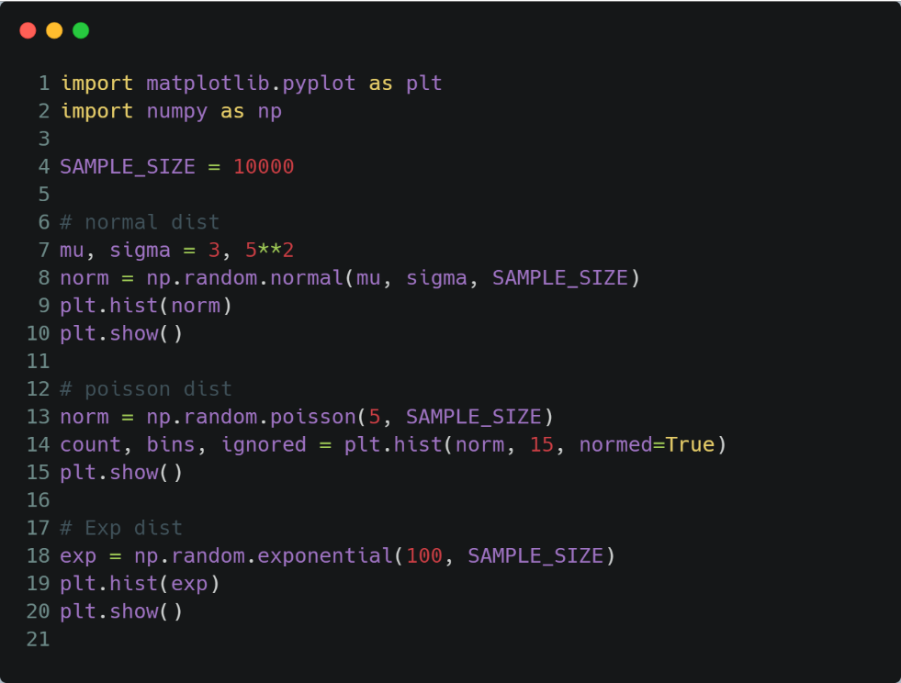

OUTPUT

Normal Distribution

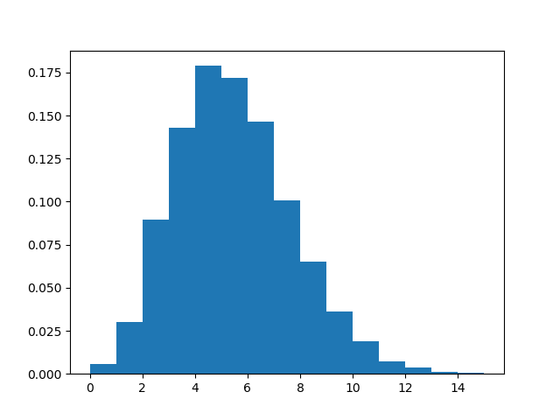

Poisson Distribution

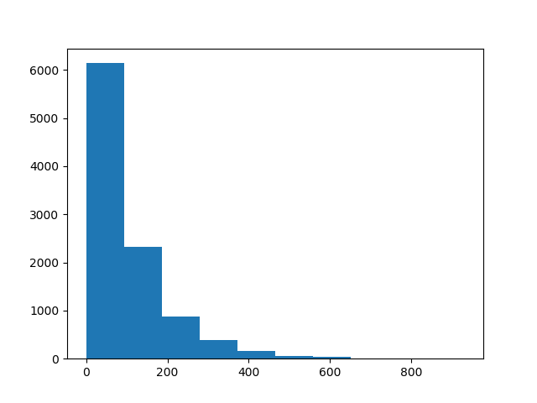

Exponential Distribution